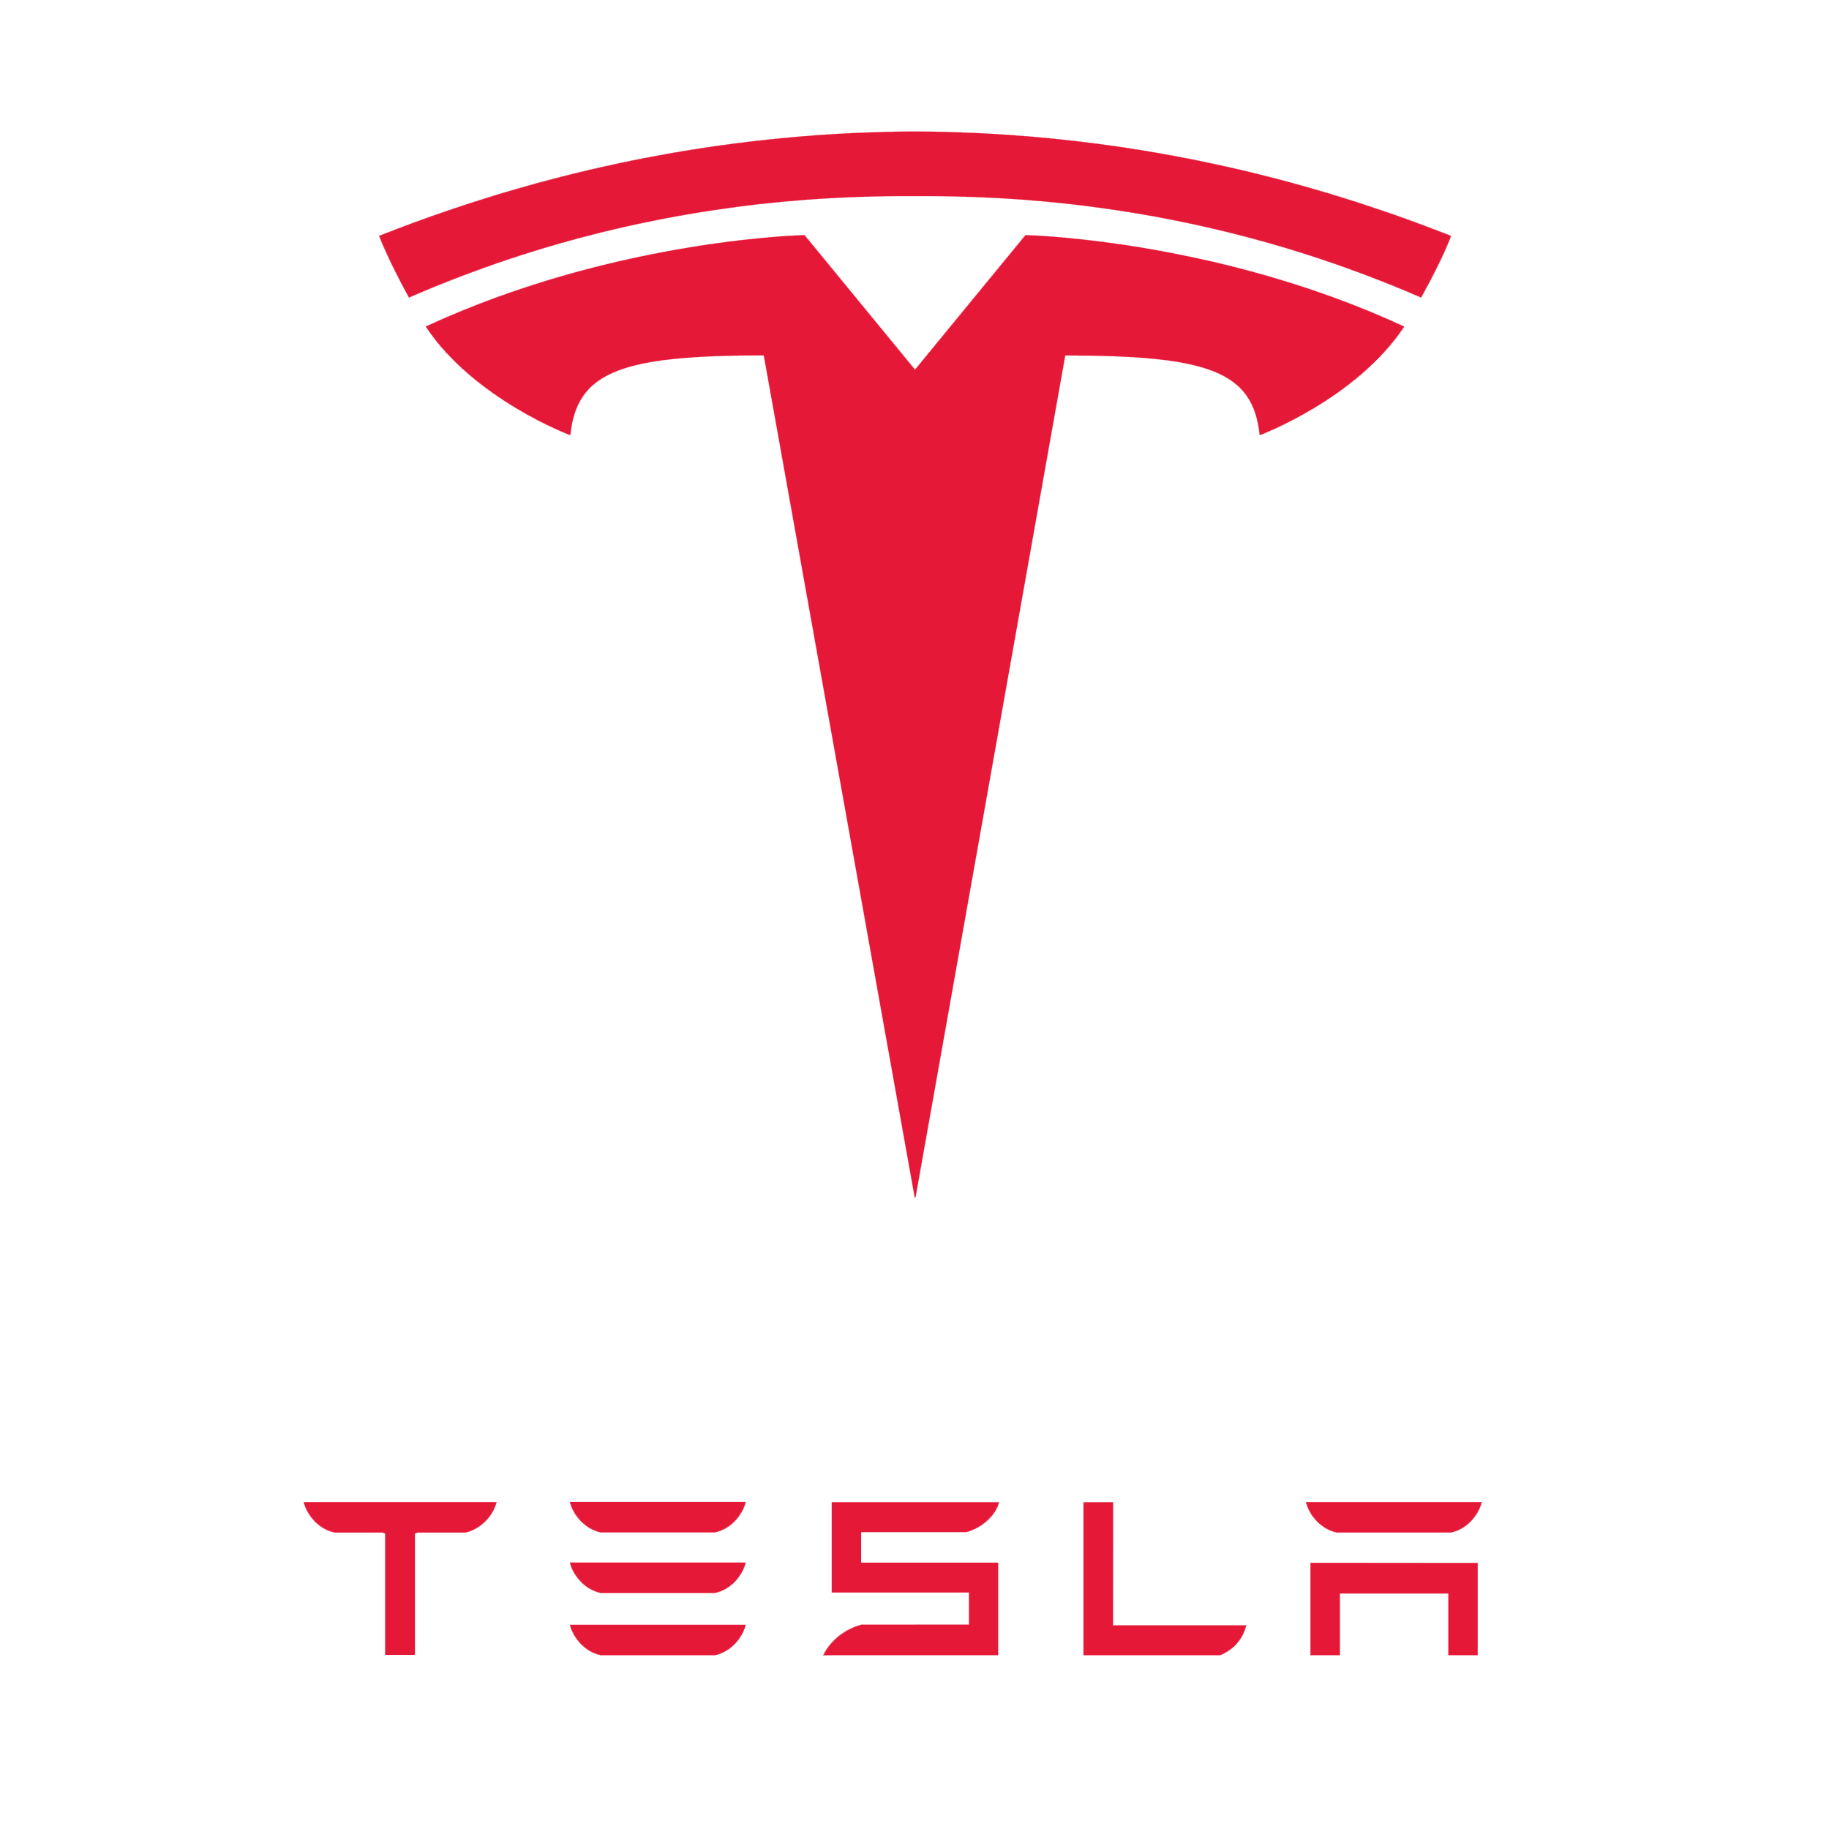

Phase 1 Deliverables

MKTG 361, Section 2

02/06/19

Aaron Kerestes

To: elonmusk@tesla.com

From: [intern@tesla.com](mailto:intern@tesla.com)

Date: 02/06/19

Subject: Tesla Deliverables

**Overview:**

Tesla is a primarily automotive based company that currently operates out of Fremont, California. Their mission to accelerate the world’s transition towards a movement that promotes sustainability and a healthy environment into the future.

When it comes to marketing your products, it is important that you meet your deadlines. With a company that is as famous as Tesla, it is important for them to meet the deadlines that they set for their cars. Unfortunately for Tesla, they did not meet expectations when it came to releasing the Model 3. Elon Musk tweeted last July that there would be over 1000 Model 3 available and that in September there would be over 1500 Model 3s available. However, they only produced 260 which was 84% lower than what Musk had promised (Fortune, 2017). This could cause several marketing problems for Tesla. An example of these problems would be that this could make customers think that Tesla is not reliable when it comes to release dates, thus causing them to lose out on potential sales.

For a company that’s main goal is to have a zero-emission future, their factories seem to produce mass amounts of pollution. Tesla’s factory in Freemont, California was fined $139,000 for producing excess air pollution (San Francisco Chronicle, 2018). That is extremely ironic for a company such as Tesla, a company that is constantly talking about how suitable all their cars are. This puts a bad name on Tesla as it seems that are not a completely energy efficient company, that could cause people to be less inclined to buy a Tesla. However, if they are able to fix these pollution problems, it would be great for their marketing as it would show they make energy efficient cars in a factory that is ecologically sustainable.

Finally, a last challenge that Tesla faces with their marketing strategy is how to effectively communicate the safety of their vehicles to stakeholders. In one of their released Vehicle Safety reports, the Tesla communication team explained that, “the safety of our customers is our top priority, which is critical that we design and build the safest cars in the world”. (Q3 2018 Vehicle Safety Report). Tesla prides itself on being able to give their drivers a sense of security and safety when these people choose to use their vehicles. With that being said, a Tesla Model X was involved in a fatal accident within the last year. At the time of the crash, the vehicle was operating under Tesla’s self-autonomous driving software known as *Autopilot.* This drew criticism from many people especially in light of the statements that the company had released in their report. A large concern that both current and potential Tesla customers has to do with the false sense of complacency that they feel *Autopilot* lulls drivers into. Tesla’s marketing strategy will face problems if the public perception of their systems is that they cause users to become overly confident in the capabilities of the vehicle.

**SWOTT Analysis:**



*Figure 1.* SWOTT Analysis

Tesla’s major competitors are Ford Motor Company, General Motors, Toyota and other automotive vehicles in the market as well.  Tesla does not sell their cars through advertisement but through their customer's loyalty program. Their customers stand by what the company is known for, and that is, zero-emission. Not only does Tesla produce zero-emission vehicles but they also provide solar panels and power walls for the consumers. Tesla is not the only company that is producing electric cars. They have much more competitors in the market who values their vehicles at a much lower price range. Even though the sales in revenue are increasing, with the use of cash, research, innovation, and buildings the company will experience a loss in the upcoming years. Especially since the company is not confident that they will be able to pay back their, “$1.8 billion bonds” according to CNN. In the long-run Tesla still has more ways to go through the number of vehicles being produced on a weekly basis and the cost of their futuristic ideas.

Referencing figure 1, particularly threats; Tesla is facing many new competitors as it is one of the first startups to become successful in the automotive and energy industry. The major competitors in the automotive industry include companies such as Ford, GM, Volkswagen, and Toyota (Investopedia, 2018). Traditional gasoline car companies are increasing their transition to electric vehicles. By Q4 of 2018, car companies involved with developing and producing commercially available electric cars include BMW, Fiat Chrysler Automobiles, Ford Motor Co., General Motors, Honda, Hyundai, Jaguar / Land Rover, Kia, Mazda, Mercedes-Benz, Mitsubishi, Nissan, Subaru, Toyota, Volkswagen, and Volvo (Investopedia, 2018). These companies are all producing new electric vehicles to enter the automotive market. Cars already in the market include the Chevrolet Volt, Toyota Prius, and Honda Civic. Tesla’s unique selling proposition is that they are the first electric car startup to become successful while using many innovative ideas. Tesla has created, and now dominates, the market for luxury, long-range electric automobiles, a market that is distinct from both the market for less expensive electric vehicles and the market for luxury gas-powered vehicles (Team, 2015). Tesla also creates unique selling propositions by allowing free supercharging to those who purchase a Model 3, as well as the integration of smart technology in the car. These USP’s ensure that consumers in the automotive industry will consider Tesla when surveying electric vehicles.

**Target Market:**

Tesla has 3 top target markets in their industry. When it comes to bringing in clientele, the most frequent purchasers of this company are the upper-middle class segment, whose income is above $100,000 a year. Tesla has a prominent age group between 35-64 year’s old who are very tech-savvy. They also draw in another specific target market that not many automotive industries do: the green consumers.

**Primary**

The most prominent target markets are the upper-middle class segment whose income is above $100,000 a year. In the article, Tesla has a new kind of buyer, Kirsten Korosec states, “Only 25% of new Model S Buyers have salaries under $100,000”. Tesla’s price ranges from anywhere between $70,000-138,000. The reason Tesla’s average price range is a lot higher than normal competitors due to their electric car production (Investopedia, 2018). This new innovative technology makes it extremely expensive to produce the Model S and X cars. In 2017, Tesla took a different approach to their target market, by launching a new series called ‘Model 3’. This model was expected to target the more middle class individuals. Model 3 is sold at $35,000, which is $35,000 lower than the cheapest car before it was released. The rapid increase of the production level for Model 3 is what made the car much more affordable to everyday consumers while still incorporating a tech-savvy feel to the car.

**Secondary**

In this day in age, young individuals are starting to develop their life a bit later, which is the reason why tesla age group is ranges between the ages of 35-64 year olds. On Investopedia their statistics display the age group of 18-44year olds consume 33.2% of the buying market, while another 50.6% of the buying market comprises of 45-64 years old (Investopedia, 2018). This age group comprises of the starting point to millennials. Millennials are fully adapted to the technological innovations Tesla has to offer while the older end of the age spectrum are the working business men/women that are up-to-date on how technology is shifting. In order to operate any car within Tesla, the owner’s must have a high level of technological knowledge.

**Tertiary**

The final group of targeted individuals is the consumers who ultimately want a healthier environment. According to an article from Investopedia, the demand for electric vehicles is driven by both the rising costs of gasoline, and a universal desire to lower the carbon footprint. The company mentions in its Buyer Profile its direct effort to target consumers who are green-friendly. The green-friendly consumers who are buying from Tesla are not designated to any particular generation. In the same article from Investopedia, the green energy aspect of the car is attractive to everyone from business executives to entry-level luxury buyers. Tesla ultimately was able to target an environmentally conscious market and incorporate “elements of luxury and elite status” (Investopedia, 2018) and attract consumers from a variety of age groups.

**Summary:**

As Tesla leads the way into a sustainable future, its implementation of marketing towards the upper-middle class, tech-savvy families, and customers with a conscious effort to help the environment fuels our company. Our SWOTT analysis entails strengths within our innovation and our sales growth as well as weaknesses seen in our cash on-hand and debt. The electric vehicle industry becomes more competitive every year, with new vehicles being introduced from Ford and General Motors. With the competition increasing year by year, Tesla’s ability to affectively target eco-friendly, young and upper-middle class consumers shows that our sales growth directly stems from these demographics. While Tesla’s main factories are not entirely environmentally friendly, and the inefficiency of their production line has proven to be a burden, the company is currently working to find efficient solutions for these issues. With an affordable Model 3 on the market, reliable solar energy components and other incentives to include Tesla’s products into everyday lives, the company’s future looks up to providing sustainable energy to consumers all over the world.

Works Cited

Baker, D. R. (2018, March 02). Tesla touts its emissions-free cars; its factory got fined for polluting. Retrieved January 31, 2019, from <https://www.sfchronicle.com/business/article/Tesla-touts-its-emissions-free-cars-Its-> factory-12721363.php

Korosec, K. (2015, July 29). Tesla has a new kind of buyer. Retrieved January 31, 2019, from <http://fortune.com/2015/07/29/tesla-millennials/>

Korosec, K. (2017, October 2). Tesla's Model 3 Deliveries Missed Elon Musk's Expectations by a Long Shot. Retrieved January 31, 2019, from <http://fortune.com/2017/10/02/tesla-> model-3-production/

Primary Target Market. (n.d.). Retrieved January 31, 2019, from <https://teslamotorsdeca.weebly.com/primary1.html>

Q3 2018 Vehicle Safety Report. (2018, October 04). Retrieved January 31, 2019, from https://www.tesla.com/blog/q3-2018-vehicle-safety-report

Team, T. (2015, July 02). Tesla's Unique Position In The Car Market Is One Of Its Biggest Strengths. Retrieved January 31, 2019, from <https://www.forbes.com/sites/greatspeculations/2015/07/02/teslas-unique-position-in-the-> car-market-is-one-of-its-biggest-strengths/#781af6623ad7

Who are Tesla's (TSLA) Main Competitors? (2019, January 07). Retrieved January 31, 2019, from <https://www.investopedia.com/ask/answers/120314/who-are-teslas-tsla-main-> competitors.asp

Zucchi, K. (2018, November 08). What Drives Consumer Demand for Tesla? Retrieved January 31, 2019, from <https://www.investopedia.com/articles/personal-finance/021715/what-> drives-consumer-demand-tesla.asp